 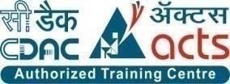

INSTITUTE FOR ADVANCED COMPUTING AND SOFTWARE DEVELOPMENT AKURDI, PUNE

Documentation On

“KrishiKart”

(Empowering Farmers, Enriching Consumers)

PG-DAC MARCH 2023

# Submitted By:

Group No: 101

Roll No. Name:

233220 Suraj Amol Jagdale

233163 Krishna Kant Srivastava

Mrs. Monika Ma’am

# Mrs. Harshal Sir Mr. Rohit Puranik

Project Guide Centre Coordinator

# ABSTRACT

KrishiKart is a web application developed for farmers. This application gives support to the village farmers who want to use this facility and who want to learn how it is possible and how they can use e -farming to sell their products

If the farmers have knowledge of computer and mobiles then they can directly register in the site

and sell their product otherwise, they can contact company’s computer professional who will schedule classes to teach the basics of computers and internet. They can know how they can open this site, and register with it and sell their products online etc.

In the existing system buying and selling a product is done manually. Price of the product is fixed by

the seller. All the details of the product to be sold or purchased is maintained manually. Sellers or

buyers not able to get the complete information about the product.

# 

# ACKNOWLEDGEMENT

I take this occasion to thank God, almighty for blessing us with his grace and taking our endeavor to a successful culmination. I extend my sincere and heartfelt thanks to our esteemed guide, Mrs. Monika Ma’am & Mr. Harshal Sirfor providing me with the right guidance and advice at the crucial juncture sand for showing me the right way. I extend my sincere thanks to our respected Centre Co- Ordinator Mr. Rohit Puranik, for allowing us to use the facilities available. I would like to thank the other faculty members also, at this occasion. Last but not the least, I would like to thank my friends and family for the support and encouragement they have given me during the course of our work.

Suraj Amol Jagdale (233220)

Krishna Kant Srivastava (233163)

# Table of Contents

ABSTRACT 2

ACKNOWLEDGEMENT 3

INTRODUCTION 7

FEATURES 7

* 1. PROJECT OBJECTIVE 8
  2. PROJECT OVERVIEW 8
  3. PROJECT SCOPE 9
  4. STUDY OF THE SYSTEM 9
     1. MODULES 9

SYSTEM ANALYSIS 13

* 1. EXISTING SYSTEM 13
  2. PROPOSED SYSTEM 13
  3. SYSTEM REQUIREMENT SPECIFICATION 13
     1. GENERAL DESCRIPTION 14
     2. SYSTEM OBJECTIVES 14
     3. SYSTEM REQUIREMENTS 14

SYSTEM DESIGN 17

* 1. INPUT AND OUTPUT DESIGN 17
     1. INPUT DESIGN 17
     2. OUTPUT DESIGN 17

DATABASE DESIGN 19

* 1. DATABASE 19
  2. SYSTEM TOOLS 19
     1. FRONT END 19
     2. BACKEND 19

DIAGRAMS……………………………………………………………………………………. 21

4.1 USE CASE DIAGRAM………………………………………………………………...21

4.2 ER DIAGRAM………………………………………………………………………… 23

4.3 CLASS DIAGRAM………………………………………………………………….…….23

4.4 ACTIVITY DIAGRAM……………………………………………………………..……..25

4.5 DATA FLOW DIAGRAM………………………………………………………………...28

4.6 SEQUENCE DIAGRAM…………………………………………………………………..30

TABLE STRUCTURE 31

PROJECT DIAGRAMS 33

CONCLUSION 39

REFERENCES 40

**LIST OF FIGURES**

##### FIGURE 1: USE CASE DIAGRAM 21

FIGURE 2: E-R DIAGRAM 23

##### FIGURE 3: CLASS DIAGRAM 24

FIGURE 4: ACTIVITY DIAGRAM 25

##### FIGURE 5: 0 LEVEL DATA FLOW DIAGRAM 28

##### FIGURE 6: 1 LEVEL DATA FLOW DIAGRAM-----------------------------------------------------------29

FIGURE 7: SEQUENCE DIAGRAM 30

# INTRODUCTION

This project is a web-based shopping system for an existing shop. An Online Shopping Management System where the Admin can Add, Delete products. A user can select a particular item to view the details, choose the number of items and fill in details like Name, Address, etc. to buy a product the project objective is to deliver the online shopping application into web platform. Online shopping is the process where by consumers directly buy goods or services from a seller in real- time, without an intermediary service, over the Internet. It is a form of farming commerce. This project is attempts provide the advantages of online shopping to customers of a real shop. It helps buying the products in the shop anywhere through internet by using an android device. Thus, the customer will get the service of online shopping and home delivery from his favorite shop.

We are well-known for delivering agricultural goods such as grains. We provide the best pricing in the market and give free home delivery services throughout India.

#### Features: -

1.Grain Marketplace: An online platform for farmers to list and sell their grain produce directly to buyers.

2.Real-Time Price Tracking: Access to current market prices and historical trends for informed selling decisions.

3.Quality Certification: Assurance of grain quality through standardized checks or third-party assessments.

4.Logistics Support: Facilitate transportation and delivery arrangements for sold grains.

5.Secure Payment Gateway: Safe and seamless transactions between farmers and buyers.

#### PROJECT OBJECTIVE

The objective of the project is to make an application in android platform to purchase items in an existing shop. In order to build such an application complete web support, need to be provided. A complete and efficient web application which can provide the online shopping experience is the basic objective of the project. The web application can be implemented in the form of an android application with web view.

#### PROJECT OVERVIEW

The central concept of the application is to allow the customer to shop virtually using the internet and allow customers to buy the items and articles of their desire from the store. The information pertaining to the products are stores on an RDBMS at the server side (store).

The server processes the customers, and the items are shipped to the address submitted by them. The application was designed into two modules first is for the customers who wish to buy the articles. Second is for the storekeepers who maintains and updates the information pertaining to the articles and those of this product is a departmental store where the application is hosted on the web and the administrator maintains the database. The application, which is deploy the customer database, the details of the items are brought forward from the database for the customer view based on the selection through the menu and the database of all the products are updated at the end of each transaction. Data entry into the application can be done through various screens designed for various levels of users. Once the authorized personal feed the relevant data into the system, several reports could be generated as per the security.

#### PROJECT SCOPE

This system can be implemented to any shop in the locality or to multinational branded shops having retail outlet chains. The system recommends a facility to accept the orders 24*7 and a home delivery system which can make customers happy. We are well-known for delivering agricultural goods such as grains. We provide the best pricing in the market and give free home delivery services throughout India.

#### STUDY OF THE SYSTEM

#### MODULES:

The project compilation we identify the responsibility be presented with the following modules and roles.

The modules involved are:

* + - * Administrator
      * Farmer
      * Buyers
      1. Administrator:

The administrator is the super user of this application. Only admin have access into this admin page. The admin can manage seller product details. The administrator has all the information about the users and about all products.

This module is divided into different sub modules.

* + - * 1. Manage Seller
        2. Manage Products
        3. Manage Users
        4. Manage Orders

##### Add Products

The admin can add the products with different categories. The products classified into different categories by name. Admin can check ISO certified products into the existing system with all its details including an image.

##### Delete Products

Administrator can delete the products based on the stock and quality of that particular product.

##### Search Products

Admin will have a list view of all the existing products. He can also search for a particular product by category name.

##### Add Supplier

Admin have the privilege to add the supplier and according supplier category he can add products and he can manage the available products stocks.

##### Remove Supplier

Admin have the privilege to remove the supplier, who give unsatisfied service to the customers.

##### Search Product

Only admin is having the privilege to add a supplier. He can search the product to manage the product.

##### Set Discount

Admin can have authority to set the specific discount to the products, so more number of customer can visit and buy products.

##### Balance Sheet

Admin can see the balance sheet of the transaction.

##### Edit Product

Admin can edit the product details if there is any update.

##### Edit Product

Seller can edit his added product.

##### Available Stocks

Seller can check the available stock per category wise, and if there is any need of updating he can do it

##### Delivered Orders

Seller can see order details of the ordered product by the customer, and delivered the product to the customer location.

##### Pending Orders

Seller can see pending orders for their respective shop.

##### Payments

Seller can see payment details of the ordered product by the customer.

##### Delete Product

Seller can delete the product details which is not available in shop.

##### Add product

Seller can add new product details in web-site.

##### Seller sign in, sign out, create account

This feature is provided to seller so he can sign in, sign out and create account for new Buy

##### Customer sign in, sign out, create account

This feature is provided to customer so he can sign in, sign out and create account for new customer.

##### Search Product

Customer can search the product as per his wish in specific category.

##### Add to Cart

Customer can add products to cart which he wants to buy the products.

##### Payments

Customer have a privilege to his order he can see his order details.

##### Order Details

Customer have a privilege to his order he can see his order details.

##### Buy Product

Customers can buy product from his cart by doing payment.

##### Wish List

Customer can have a wish list for future buying products he can add products in the wish to list.

##### Contact Seller

If due to complex graphical user interface farmer don’t know how to place order, so using the Seller contact he can also place the order.

# SYSTEM ANALYSIS

System analysis is the process of gathering and interpreting facts, diagnosing problems, and using the information to recommend improvements on the system. System analysis is a problem-solving activity that requires intensive communication between the system users and system developers.

System analysis or study is an important phase of any system development process. The system is viewed as a whole, the inputs are identified, and the system is subjected to close study to identify the problem areas. The solutions are given as a proposal. The proposal is reviewed on user request and suitable changes are made. This loop ends as soon as the user is satisfied with the proposal.

#### EXISTING SYSTEM

The current system for shopping is to visit the shop manually and from the available product choose the item farmer want and buying the item by payment of the price of the item.

* + - It is less user-friendly.
    - User must go to shop and select products.
    - It is difficult to identify the required product.
    - Description of the product limited.
    - It is a time-consuming process
    - Not in reach of distant users.

#### PROPOSED SYSTEM

In the proposed system farmers need not go to the shop for buying the products. He can order the product he wish to buy through the application in his Smartphone. The shop owner will be admin of the system. Shop owner can appoint moderators who will help owner in managing the customers and product orders. The system also recommends a home delivery system for the purchased products.

#### SYSTEM REQUIREMENT SPECIFICATION

**Purpose of Project:**

The purpose of the KrishiKart Online Shopping System is to provide a web-based platform that enables

sellers to register and manage agricultural products, and customers to browse, select, and purchase these

products. The system facilitates secure transactions, communication between users, and administrative control.

**Scope of project:**

The KrishiKart project encompasses the development of a web application that consists of frontend and backend components. Sellers can register, add, update, and delete products in various categories. Customers can browse products, add items to their cart, place orders, and make secure payments. Admins manage users, products, and security settings.

**Definitions:**

SRS: Software Requirements Specification

API: Application Programming Interface

JPA: Java Persistence API

UI: User Interface

**Project Description:**

The system consists of two parts. A web application which can provide the online shopping service for the farmers to access the web service from his Smartphone/System. Web application should be able to help the farmers for selecting his item and to help the owner in managing the orders from the customers.

**User Characteristics:**

Farmer: Manages products, interacts with customers.

Buyer: Browses, selects, and purchases products.

Admin: Manages users, products, and security settings.

**SYSTEM OBJECTIVES**

* To provide a Web application for online shopping of products in an existing shop.
* To provide an online shopping web site for the same shop.

**SYSTEM REQUIREMENTS**

1. **FUNCTIONAL REQUIREMENTS**

**Farmer Functionality**

1. **Register and Authenticate as a Seller:**

Sellers can create accounts by providing necessary information such as name, contact details, and a secure password. After registration, they can log in using their credentials.

1. **Add, Update, and Delete Products:**

Sellers have the ability to add new products to their inventory. They can provide details like product name, description, price, quantity, and images. They can also update these details and delete products that are no longer available.

1. **Manage Product Categories:**

Sellers can organize their products into different categories such as Machinery, Seeds, Fertilizer, etc. This categorization helps customers easily find the products they are interested in.

1. **Communicate with Customers:**

Sellers can engage with customers by responding to inquiries, providing additional information about products, and addressing any concerns through messaging or contact forms.

**Customer Functionality**

**1.Register and Login:**

Customers can create accounts by registering with their personal details and a password. They can then log in using their credentials to access personalized features.

1. **Browse Products by Category:**

Customers can explore the range of products available on the platform, filtering and sorting them based on different categories like Machinery, Seeds, Fertilizer, etc.

1. **View Product Details:**

Customers can view detailed information about a specific product, including its name, description, price, images, and seller information.

1. **Add Items to the Cart:**

Customers can add products they wish to purchase to their shopping cart. The cart maintains a running total of the selected items.

1. **Proceed to Checkout and Make Payments:**

After reviewing the items in their cart, customers can proceed to the checkout process. They can enter shipping details and choose a secure payment method to complete the purchase.

1. **Contact Sellers for Inquiries:**

Customers can initiate communication with sellers by sending inquiries about products or other related matters through messaging features.

**Admin Functionality**

1. **Admin Login:**

Administrators have a secure login interface to access the admin dashboard and perform administrative tasks.

1. **Manage User Accounts:**

Administrators can create new user accounts, update existing user information, and delete accounts as needed. This helps maintain accurate user data and access control.

1. **Manage Products and Categories:**

Admins have the authority to oversee the product database. They can add new product categories, manage existing ones, and ensure accurate product information.

1. **Configure System Security Settings:**

Admins can configure security settings such as password policies, access controls, and user roles. This ensures the integrity and security of the system.

**2. NON-FUNCTIONAL REQUIREMENTS**

1. **Efficiency requirement**

When an online shopping cart android application implemented customer can purchase product in an efficient manner.

1. **Reliability requirement**

The system should provide a reliable environment to both farmers and shop owner. All orders should be reaching at the admin without any errors.

1. **Usability requirement**

The Web application is designed for user friendly environment and ease of use.

1. **Implementation requirement**

Implementation of the system using React in front end with Spring Boot as back end and it will be used for database connectivity. And the database part is developed by MySQL. Responsive web designing is used for making the website compatible for any type of screen.

1. **Delivery requirement**

The whole system is expected to be delivered in one month of time with a weekly Evaluation by the project guide.

# SYSTEM DESIGN

System design is the solution for the creation of a new system. This phase focuses on the detailed implementation of the feasible system. Its emphasis on translating design. Specifications to performance specification. System design has two phases of development.

* Logical Design
* Physical Design

During logical design phase the analyst describes inputs (sources), outputs(destinations), databases (data sores) and procedures (data flows) all in a format that meets the user requirements. The analyst also specifies the needs of the user at a level that virtually determines the information flow in and out of the system and the data resources. Here the logical design is done through data flow diagrams and database design. The physical design is followed by physical design or coding. Physical design produces the working system by defining the design specifications, which specify exactly what the candidate system must do. The programmers write the necessary programs that accept input from the user, perform necessary processing on accepted data and produce the required report on a hard copy or display it on the screen.

#### INPUT AND OUTPUT DESIGN

##### INPUT DESIGN:

Input design is the link that ties the information system into the world of its users. The input design involves determining the inputs, validating the data, minimizing the data entry and provides a multi-user facility. Inaccurate inputs are the most common cause of errors in data processing. Errors entered by the data entry operators can be controlled by input design. The user-originated inputs are converted to a computer-based format in the input design. Input data are collected and organized into groups of similar data. Once identified, the appropriate input media are selected for processing. All the input data are validated and if any data violates any conditions, the user is warned by a message. If the data satisfies all the conditions, it is transferred to the appropriate tables in the database. In this project the student details are to be entered at the time of registration. A page is designed for this purpose which is user friendly and easy to use. The design is done such that users get appropriate messages when exceptions occur.

##### OUTPUT DESIGN:

Computer output is the most important and direct source of information to the user. Output design

is a very important phase since the output needs to be in an efficient manner. Efficient and intelligible output design improves the system relationship with the user and helps in decision making. Allowing the user to view the sample screen is important because the user is the ultimate judge of the quality of output. The output module of this system is the selected notifications.

# DATABASE DESIGN

* 1. **DATABASE**

Databases are the storehouses of data used in the software systems. The data is stored in tables inside the database. Several tables are created for the manipulation of the data for the system. Two essential settings for a database are

* Primary key - the field that is unique for all the record occurrences
* Foreign key - the field used to set relation between tables Normalization is a technique to avoid redundancy in the tables.
  1. **SYSTEM TOOLS**

The various system tools that have been used in developing both the front end and the back end of the project are being discussed in this chapter.

##### FRONT END:

React is a library which is developed by Facebook are utilized to implement the frontend. React (also known as React.js or ReactJS) is a [free and open-source](https://en.wikipedia.org/wiki/Free_and_open-source_software) [front-end](https://en.wikipedia.org/wiki/Front_end_and_back_end) [JavaScript](https://en.wikipedia.org/wiki/JavaScript_library) [library](https://en.wikipedia.org/wiki/JavaScript_library) for building [user interfaces](https://en.wikipedia.org/wiki/User_interfaces) or UI components. It is maintained by [Facebook](https://en.wikipedia.org/wiki/Facebook%2C_Inc) and a community of individual developers and companies. React can be used as a base in the development of [single](https://en.wikipedia.org/wiki/Single-page_application) [page](https://en.wikipedia.org/wiki/Single-page_application) or mobile applications. However, React is only concerned with state management and rendering that state to the [DOM,](https://en.wikipedia.org/wiki/Document_Object_Model) so creating React applications usually requires the use of additional libraries for routing, as well as certain client-side functionality.

##### BACKEND:

The back end is implemented using MySQL which is used to design databases.

##### MySQL:

MySQL is the world's second most widely used open-source relational database management system (RDBMS). The SQL phrase stands for Structured Query Language. An application software called Navicert was used to design the tables in MySQL.

##### Spring-Boot:

This is used to connect MYSQL and fetch data from database and store the data in database. The Spring Framework is a[n application framework](https://en.wikipedia.org/wiki/Application_framework) and [inversion of control](https://en.wikipedia.org/wiki/Inversion_of_control) [container](https://en.wikipedia.org/wiki/Servlet_container) for the [Java](https://en.wikipedia.org/wiki/Java_platform) [platform.](https://en.wikipedia.org/wiki/Java_platform) The framework's core features can be used by any Java application, but there are extensions for building web applications on top of the [Java EE](https://en.wikipedia.org/wiki/Java_EE) (Enterprise Edition) platform. Although the framework does not impose any specific [programming model,](https://en.wikipedia.org/wiki/Programming_model) it has become popular in the Java community as an addition to the [Enterprise JavaBeans](https://en.wikipedia.org/wiki/Enterprise_JavaBeans) (EJB) model. The Spring Framework is Open-source Framework.

# 

# Diagrams

# USE CASE DIAGRAM

# 

# 

# 

# Fig.1 Use Case Diagram

# E-R DIAGRAM

Entity Relationship Diagram is used to define the data elements and relationship for a specified application. It develops a conceptual design for the database. It also develops a very simple and easy to design view of the data.

In Entity Relationship Diagram, the data is represented by using various components including entities, attributes, relationships (One To Many / Many To Many etc.)

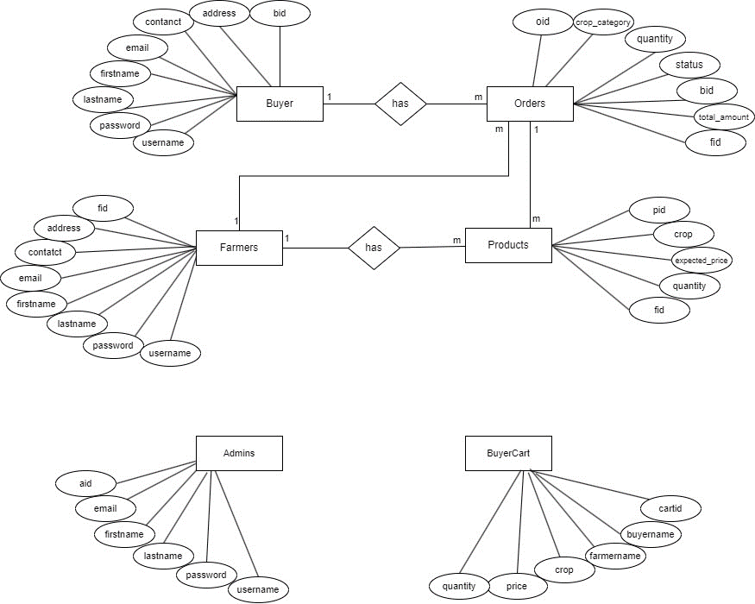

# Fig.2 E-R Diagram

# CLASS DIAGRAM

Class diagram is a static diagram. It represents the static view of an application. Class diagram is not only used for visualizing, describing, and documenting different aspects of a system but also for constructing executable code of the software application. Class diagram describes the attributes and operations of a class and also the constraints imposed on the system. The class diagrams are widely used in the modelling of object oriented systems because they are the only UML diagrams, which can be mapped directly with object-oriented languages.

Class diagram shows a collection of classes, interfaces, associations, collaborations, and constraints. It is also known as a structural diagram. The purpose of the class diagram can be summarized as:-

1. Analysis and design of the static view of an application.
2. Describe responsibilities of a system.
3. Base for component and deployment diagrams.
4. Forward and reverse engineering.

# 

# Fig.3 Class Diagram

# ACTIVITY DIAGRAM

# 

# 

# 

# Fig.4 Activity Diagram

# DATA FLOW DIAGRAMS

# 5.1 Zero Level DFD Diagram

# 

# Fig. 5.1 Zero Level Data Flow Diagram

# First Level DFD Diagram

# 

# 

# 

# Fig. 5.2 First Level Data Flow Diagram

# SEQUENCE DIAGRAM

# 

# Fig. 6 Sequence Diagram

# TABLE DIAGRAMS

# 

# 

# 

# 

# 

# 

# PROJECT DIAGRAMS

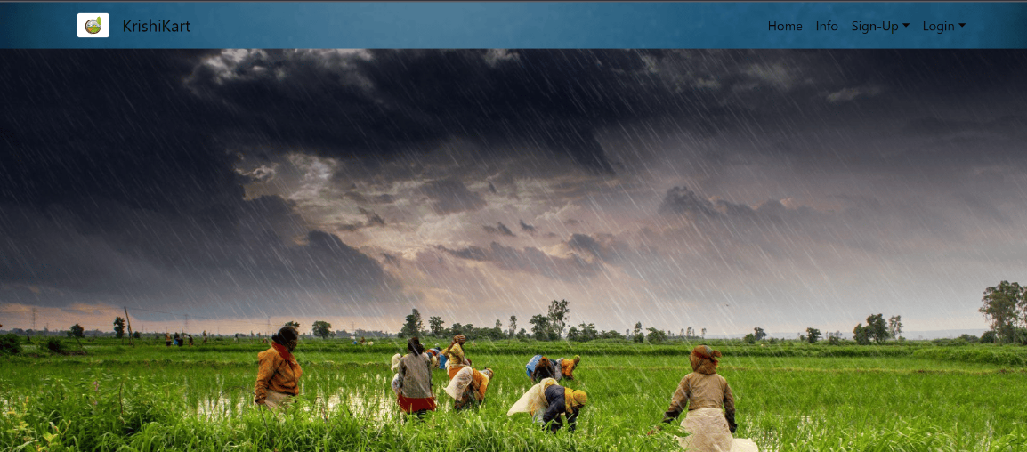

Homepage

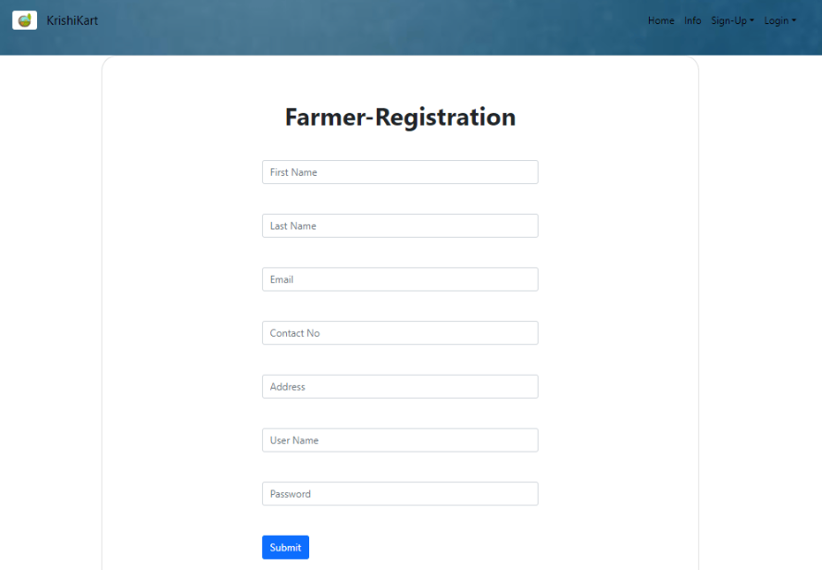

Sign-Up page

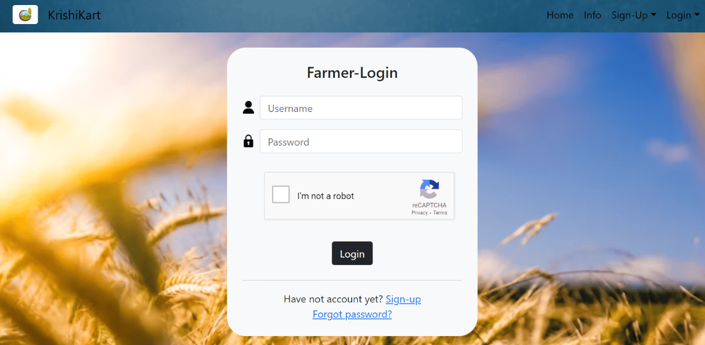

Login Page

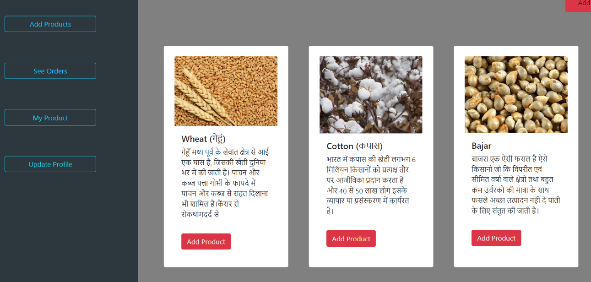

Click on add products to add product

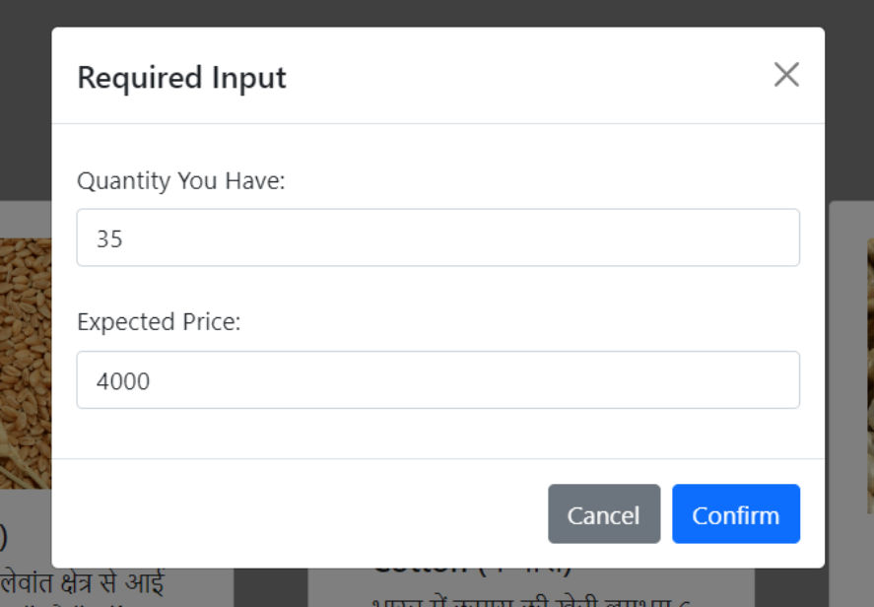

Enter details of product

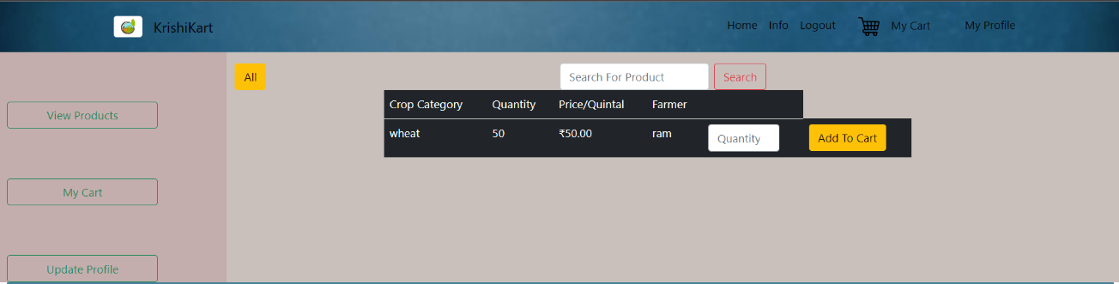

Buyer will see listed products

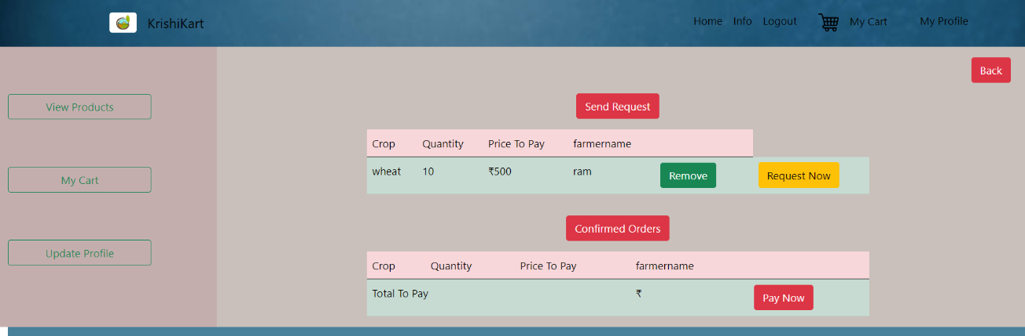

Buyer cart : buyer will request the product to farmer

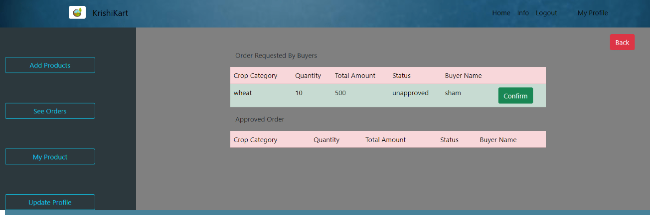

Farmer will approve order

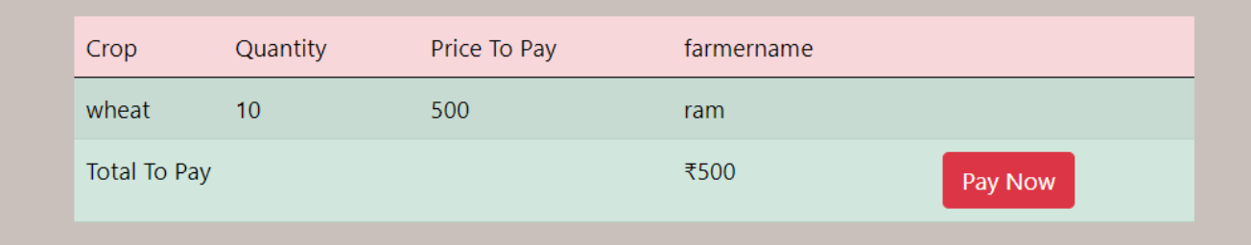

Buyer will pay

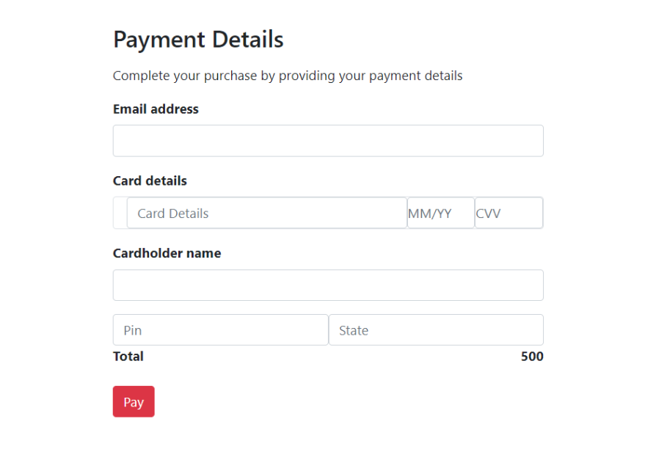

Buyer will proceed for checkout

# 

# CONCLUSION

The project entitled **KrishiKart** is completed successfully.

The system has been developed with much care and free of errors and at the same time it is efficient and less time consuming. The purpose of this project was to develop a web application and an android application for purchasing items from a shop.

This project helped us in gaining valuable information and practical knowledge on several topics like designing web pages using React.js, usage of responsive templates, designing of android applications, and management of database using MySQL. The entire system is secured. Also, the project helped us understanding about the development phases of a project and software development life cycle. We learned how to test different features of a project.

This project has given us great satisfaction in having designed an application which can be implemented to any nearby shops or branded shops selling various kinds of products by simple modifications.

There is a scope for further development in our project to a great extent. A number of features can be added to this system in future like providing moderator more control over products so that each moderator can maintain their own products. Another feature we wished to implement was providing classes for customers so that different offers can be given to each class. System may keep track of history of purchases of each customer and provide suggestions based on their history. These features could have implemented unless the time did not limit us.

# REFERENCES

1. JavaScript Enlightenment, Cody Lindley-First Edition, based on JavaScript 1.5, ECMA-262,

Edition

1. Mc Graw Hill’s, Java: The complete reference 7thEdition, Herbert Scheldt
2. Complete CSS Guide, Maxine Sherrin and John Allsopp-O'ReillyMedia; September 2012

#### ONLINE REFERENCE

* 1. [www.w3school.com](http://www.w3school.com/)
  2. [www.javatpoint.com](http://www.javatpoint.com/)
  3. https://reactjs.org/